SantaFest
A Two-Day Event
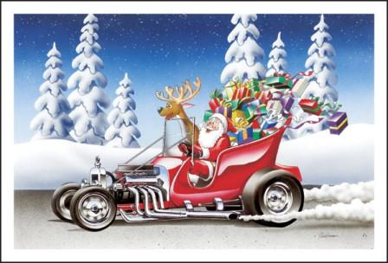
Friday December 6
Parade of Lights Food Drive
5pm on Mesquite Blvd

Saturday December 7
Toy Drive Car Show
10 am to 2 pm in the Eureka Casino Parking Lot Hosted by the Mesquite Rotary Club and Over the Hill Gang Car Club  Over the Hill Gang Car Club

