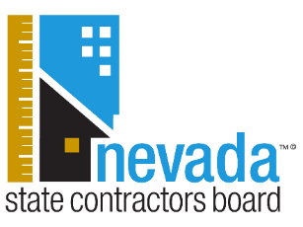

We’re in the middle of fire season and with it comes potentially dangerous weather that can harm homes. Oftentimes after a natural disaster, scammers take advantage of residents who have damage to their property. The Nevada State Contractors Board wants the public, especially vulnerable senior residents, to be aware of the warning signs of unscrupulous contractors:
- Door-to-door solicitors who try to put you on the spot to sign a contract can be a warning sign you are dealing with an unlicensed contractor. Never let individuals into your home that you have not personally invited.
- High pressured sales tactics are an intimidating and aggressive way to get homeowners to have work performed. Walk away or contact law enforcement if you ever feel threatened.
- Demands for cash payment and large down payments are an easy way for scam artists to take your money and never return. Refuse to give large cash deposits up front for materials before any work is performed. Paying by check or credit card ensures a record of the transaction and affords you the added protections of your financial institutions.

The Nevada State Contractors Board encourages residents to hire licensed contractors for any home repair work, not just to prevent scams, but for protection reasons as well. In the event a homeowner has been damaged by a licensed contractor’s failure to appropriately execute a contract and have exhausted all other means of recovery, the Residential Recovery Fund may be of assistance. In the past 20 years, the Residential Recovery Fund has awarded more than $14.2 million to harmed homeowners. Homeowners who have concerns with a residential project are encouraged to file a complaint with the Nevada State Contractors Board and have up to four years from the date the work was performed to do so. This may include alleged workmanship issues, failure to adhere to the terms of a contract, or other project matters homeowners are unable to resolve with their contractor directly.

For more information on hiring a licensed contractor and the Residential Recovery Fund, please visit www.nscb.nv.gov, or call the Nevada State Contractors Board directly at 702-486-1100 (Southern Nevada) or 775-688-1141 (Northern Nevada).

