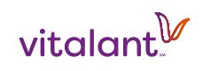
Vitalant Media Contact
Mike Doria
702.444.6629
mdoria@vitalant.org

FOR IMMEDIATE RELEASE

Vitalant & CasaBlanca Resort & Casino Partner for an Independence Day Blood Drive

Donors Will Receive Buffet Voucher & T-Shirt

Mesquite, Nev. (June 14, 2024) – Vitalant and CasaBlanca Resort & Casino will give the greater Mesquite community a unique way to exhibit patriotism with a blood drive on July 4 inside the Cortez Ball Room at CasaBlanca. The blood drive is crucial to keeping the community's blood supply at an adequate level.

The drive will run from 9 a.m. to 2 p.m., giving people plenty of time to donate after the parades and before the backyard barbeques and fireworks later that night. While all blood types are needed for this drive, particular emphasis is on the O blood types. O-positive can help any patient with a positive blood type. O-negative can help any patient with any blood type.

"In an emergency, when there's no time to determine a patient's blood type, doctors will reach for o-negative blood because of its universal quality. For that reason, o-negative is tough to keep on shelves," said Vitalant Communications Manager Mike Doria

With the start of trauma season — a period marked by increased outdoor injuries resulting in more trips to the emergency room and fewer blood donors due to summer break and family vacations/events — Vitalant encourages first-time and existing donors to roll up their sleeves at this drive.

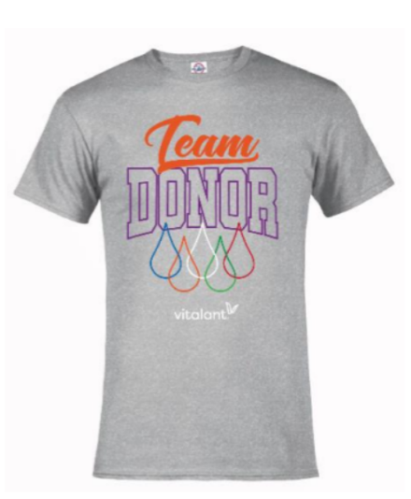
CasaBlanca Resort & Casino will thank donors at this drive by offering a voucher for a free breakfast, lunch or dinner at the Mesa Buffet.

Additionally, Vitalant will give all donors a “Team Donor T-shirt” (must be opted into Donor Rewards program. Shirts will be mailed to donors).

Anyone who would like to donate can sign up for an appointment at the drive by logging on to www.vitalant.org/mequite, downloading and using the Vitalant app, or calling 877-25-VITAL (877-258-4825).
- MORE -
The federal government lifted many of the previous restrictions that previously excluded some people from donation, which means they are now free to donate. Donors can check their eligibility at www.vitalant.org/eligibility. Also, donors who are type O, A negative, or B negative are encouraged to make a power red donation if possible.

ABOUT VITALANT:
Vitalant (Vye-TAL-ent)) is one of the nation’s largest nonprofit blood and biotherapies healthcare organizations, providing hospitals and patients across the U.S. a safe blood supply, specialized laboratory services, transfusion medicine expertise and world-renowned research. Individuals generously donating blood, volunteering and giving financially are essential to our lifesaving mission. Visit vitalant.org

ABOUT MESQUITE GAMING:
Mesquite Gaming, located 77 miles north of Las Vegas, includes CasaBlanca Resort-Casino-Golf-Spa and Virgin River Hotel/Casino/Bingo. A premier golf destination, Mesquite Gaming owns and operates CasaBlanca Golf Club and Palms Golf Club. Combined, the two properties feature 1,186 guest rooms, 76,000 square feet of casino space, with 2,000 slot machines and 36 gaming tables, and 70,000 square feet of meeting and convention space. For more information, visit mesquitegaming.com.

###

