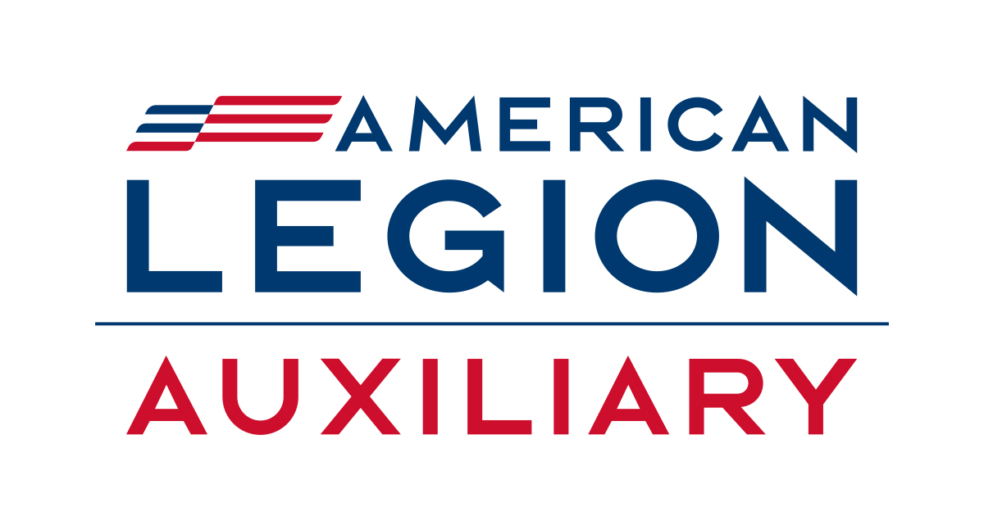

National Headquarters
3450 Founders Road, Indianapolis, IN 46268
www.ALAforVeterans.org
Contact: Jennifer Donovan, jdonovan@alaforveterans.org, 317-569-4566

Show your support this Veterans Day to those who served

INDIANAPOLIS — Veterans Day, Nov. 11, is a day set aside to remember and recognize veterans who have served in the U.S. military or who are currently serving to protect our freedoms.

Members of The American Legion Family organizations — The American Legion, American Legion Auxiliary, and Sons of The American Legion — will be hosting special events throughout the country to show their support at local post homes and in their communities. But you don’t have to be part of the Legion Family to make a difference in the life of a veteran.

We want as many veterans as possible to take part in these events and to take advantage of the special offers at restaurants and stores, but we know not all veterans will be able. Consider those veterans who can’t easily leave their home, who feel isolated, or just don’t feel comfortable going out alone.

Anyone can make a difference. It can be as simple as a phone call or text, taking a veteran a meal, or a lunch invitation.

This Veterans Day, join The American Legion Family in a Be the One mission: Be the One to destigmatize asking for mental health support, provide peer-to-peer support and resources, and educate everyone on how they can Be the One.

Why is this important? Pentagon data has shown a rise in military suicides in the past decade. According to the U.S. Department of Veterans Affairs 2022 National Veteran Suicide Annual Report, suicide is the second leading cause of death for veterans aged 18 to 44.

How can you help?

- Ask veterans in your life how they are doing.
- Listen when a veteran needs to talk.
- Reach out when you think a veteran might be struggling.
- Those needing help are encouraged to call the Veterans Crisis Line at 988, then press 1. They may also text 838255 or visit the VA crisis line website at www.veteranscrisisline.net.

“Just be the one to save one,” said 2023-2024 ALA National President Lisa Williamson. “All those ones add up.”

About Veterans Day: Veterans Day was founded to commemorate the end of World War I on the 11th day, at the l1th the hour, in the 11th month. Since that day, it has evolved to recognize and honor all veterans.

The American Legion Auxiliary (ALA) is a community of volunteers serving veterans, military, and their families. Our members also support the mission of The American Legion in improving the quality of life for our nation’s veterans. Proud sponsor of ALA Girls Nation, National Poppy Day® and recognized for advocating for veterans on Capitol Hill, the nearly 550,000 ALA members volunteer millions of hours annually and raise millions of dollars in service to veterans, military, and their families. Founded in 1919, the ALA is one of the oldest patriotic membership organizations in the U.S.A. To learn more and to volunteer, join, and donate, visit www.ALAforVeterans.org

