Women’s History and Culture Center
February 2022 Newsletter
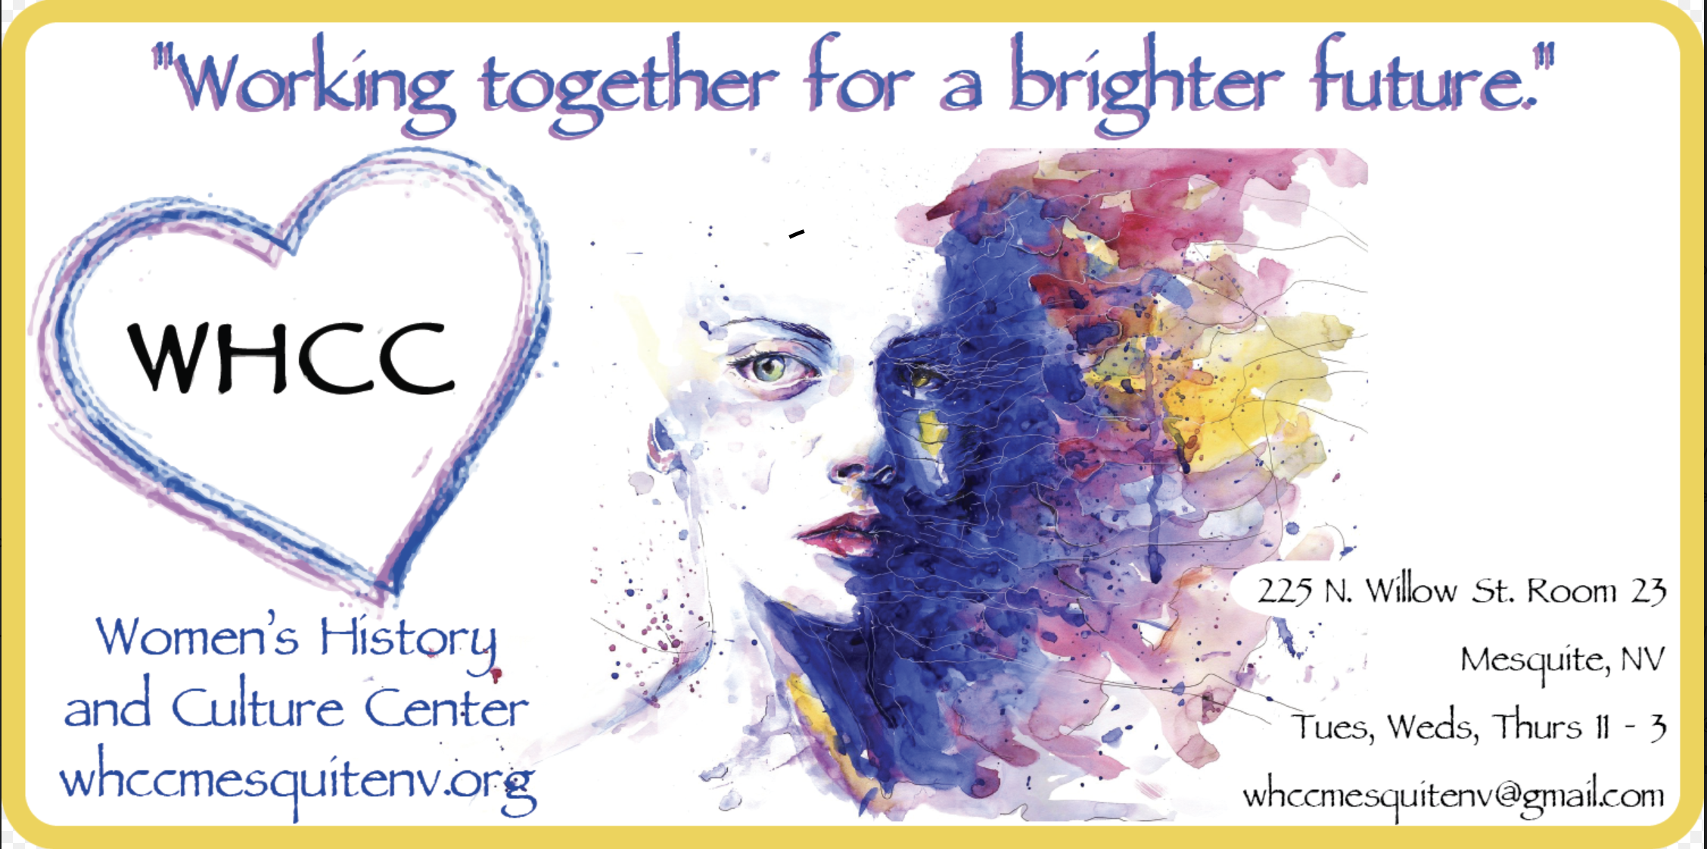

Page 1: Notes from the Editors

Page 2: Upcoming Events/Classes for February and March 2022
Page 3: Calendar of February Events/Classes at the Women’s Center
Flyers
Page 4: Beginning Step Aerobics Class starting – February 7

Page 5: Mesquite Heart Walk – February 11

Page 6: Denim and Diamonds – February 14

Page 7: CSN Personal Enrichment Classes – starting February 14

Page 8: Mesquite Western Roundup – February 25 and 26

To receive this newsletter by email, or make comments, please Email whccmesquitenv@gmail.com.
Our mailing list is private and not shared with other organizations.

Hard copies of this newsletter are available at the Women’s History and Culture Center
located at 225 N. Willow #23, Mesquite NV 89027. Mailing address is: PO Box 1502, Mesquite NV 89024.

1a | Notes From the Editors – February 2022
New Year, New Look!

Good February to all our faithful readers! Hope you enjoy the new look of our newsletter. We will be moving the history write-ups that used to be part of the newsletter to our website soon, including many highlights in history; birthdays of many women in history, photos and features that normally adorn our newsletters.

We hope, if you like reading the history pages, that you’ll go over and read them at whccmesquitenv.org under the “Women’s History” tab. This will allow us to include many features that we don’t cover in our newsletter.

The “History” will be on the Website (and always in the Center!), and the Culture (what’s happening now and upcoming), will be in our Newsletter. We also have plans for quarterly features to spotlight current culture and history in fun and creative ways!

Big News for Women’s History and Culture Center

January brought us big news! The Mesquite Chamber of Commerce announced the Women’s History and Culture Center (WHCC) winner of the 2021 Best Nonprofit in Mesquite! The award was presented at the Chamber’s State of the Chamber event, and Best of Mesquite! We are all so proud to have been among the many worthy nominated Chamber Member organizations.

Jean said, “This award comes with the efforts of many people. The combined effort of our volunteers, class facilitators, board members, community, and community partners have all played a part since our opening in 2018. We cannot do what we do without the time and talents of those who support us in so many ways.” Our award and photo of attendees from WHCC is on display at the Center. Come and see it!

New Classes and Events at WHCC

We have so many exciting things happening at the Center! We’re happy to be hosting the Desert Dames for their BUNCO on the 2nd Monday each month, as well as their Book Club on the 2nd Wednesday each month. You will want to contact them for inclusion, should you be interested in being a “Dame.”

Tami Close is hosting a very welcoming and impassioned group, “Empowered Women.” There may be a spot for you, should you be interested in joining. It’s every 1st and 3rd Thursday at 3:00 p.m. at the Center. Contact information is listed on our “Upcoming Events” page.

We host the Mesa Valley Estates ladies for a monthly outing to visit us and mingle with our members and the community. Contact us at whccmesquitenv@gmail.com to reserve a spot. Each month we choose a speaker, theme or celebration! Contact us with any questions, too!

1b

Check out our calendar to see if there’s something that interests you, and, if it’s listed as a “closed group,” feel free to contact us about how to connect with facilitators and be a part of a class.

If you have an event or a class you’d like to facilitate at the beautiful Center, let us know and we’ll look at your content, discuss what you’ll need to be successful, and include you on our calendar! Stay tuned for many cool things coming up with the addition of the beautiful “Plaza” just outside our doors.

Carol Saldivar
President

Celebrating All Cultures Art Exhibit

In partnership with the Virgin Valley Artists Association, The Women’s Center is sponsoring the February Themed Art Exhibition & Competition. The competition theme is “Celebrating All Cultures.” Please stop by the Fine Arts Gallery (15 W. Mesquite Blvd.) between January 31 and February 26 to see the wide range of entries submitted by local artists and vote for your favorite.

Women’s History Month Display at the Mesquite Library

To celebrate March, Women’s History Month, the Women’s Center is partnering with the Mesquite Library on a lobby display that will feature inspiring women from all walks of life, including the books that have been written about them. This has been a labor of love for the volunteers at WHCC, narrowing down from hundreds of women we have books on, to just a dozen or so. The exhibit will open Monday, February 14 and run through April.

Women’s Center Plaza

While March is the official Grand Opening of the Women’s Center Plaza, you don’t have to wait until then to see what this new addition to our facility looks like. The plaza is available now and can be reserved for group events. Stop by and check it out at the Women’s Center!

Volunteer and Greeter Opportunities at the Women’s Center

If you would like to learn more about the Women’s Center, there are openings for greeters and greeter back-ups. Shifts are two hours long, either 11:00 AM to 1:00 PM or 1:00 PM to 3:00 PM on Tuesdays, Wednesdays and Thursdays. This is a rewarding relaxing way to spend two hours a week while learning about amazing women in history and recent times, meeting people and making friends.

We look forward to seeing you and sharing some of the features that make the Women’s History and Culture Center so special.

Jean Watkins
Founder/Board Chair

2 | Upcoming Events
FEB  2022  Details |  | Wednesday February 2, 9, 16 and 23 at 4:00 PM: MAX Meditation Classes.  Thursday February 3 and 17 at 3:00 PM: Empowered Women Group, led by Tami Close – Call Tami at 330-710-4698 to reserve a spot. Class limited to 10 people.  Sunday February 6 and 20 at 4 PM: Wellness Craft Sundays. (Open group – Please call 208-751-7182 in advance to ensure supplies are available for each attendee.)  Monday February 7 and 21 at 2 PM: Writers’ Critique Group Facilitated by Mary Lou Ashe.  Wednesday February 9th at 1:30 PM: Desert Dames Book Club (Closed Group).  Friday February 11 from 2:00 to 4: 30 PM: Sun City Red Hatters (Closed Group).  Sunday February 13 at 10 AM: Women’s Display Set up at the Mesquite Library.  Sunday February 13 at 4 PM: Mesquite Outdoor Group (Closed Group).  Monday February 14 at 1:30 PM: Desert Dames BUNCO (Closed Group).  Wednesday February 16 at 4:00 PM: Full Moon Ceremony. Call 253-756-7003 for details.  Friday February 18 at 2 PM: Mesa Valley Estates Ladies Outing. Please Email reservation requests to whccmesquitenv@gmail.com.  Tuesday February 22 at 5:00 PM: R.A.I.S.E. Mesquite Paint Night (Closed Group).  Friday February 25 at 3 PM: Volunteer Updates.
MAR  2022  Details |  | Wednesday March 2, 9, 16 and 23 at 4:00 PM: Energy Wellness and Healing.  Thursday March 3 and 17 at 3:00 PM: Empowered Women Group, led by Tami Close – Call Tami at 330-710-4698 to reserve a spot. Class limited to 10 people.  Sunday March 6 and 20 at 4 PM: Wellness Craft Sundays. (Open group – Please call 208-751-7182 in advance to ensure supplies are available for each attendee.)  Monday March 7 and 21 at 2 PM: Writers’ Critique Group Facilitated by Mary Lou Ashe.  Wednesday March 9 at 1:30 PM: Desert Dames Book Club (Closed Group).  Sunday March 13 at 4 PM: Mesquite Outdoor Group (Closed Group).  Monday March 14 at 1:30 PM: Desert Dames BUNCO (Closed Group).  Friday March 18 at 2 PM: Mesa Valley Estates Ladies Outing. Please Email reservation requests to whccmesquitenv@gmail.com.  Friday March 25 at 3 PM: Volunteer Updates.  Friday March 25 at 4:00 PM: Full Moon Ceremony. Call 253-756-7003 for details.  Wednesday March 30 at 4 PM: Wellness Wednesday (5th Weds.) TBA Fun Craft Workshop.

February 2022 Calendar
For details on events on this month’s calendar, see Page 4 or visit Website: whccmesquitenv.org
and Facebook Group: Women's History and Culture Center, Mesquite, NV

SUN | MON | TUE | WED | THU | FRI | SAT
 |  | FEB 1 | FEB 2 | FEB 3 | FEB 4 | FEB 5
 |  |  | 4 PM  MAX  Meditation | 3 PM  Empowered Women Group
FEB 6 | FEB 7 | FEB 8 | FEB 9 | FEB 10 | FEB 11 | FEB 12
4 PM  Wellness Craft Sunday | 2 PM Writer’s Critique Group | 2 PM Library Display Committee  Planning Mtg. | 1:30 PM  Desert Dames Book Club  4 PM  MAX  Meditation | 3:15 PM Library Display Committee Planning Mtg. | 2 PM  Sun City  Red Hatters
FEB 13 | FEB 14 | FEB 15 | FEB 16 | FEB 17 | FEB 18 | FEB 19
10AM Library Display Set-Up  4 PM  Mesquite Outdoor Group | 1:30 PM  Desert Dames Bunco  3 PM  Board  Meeting |  | 4 PM  MAX  Meditation | 3 PM  Empowered Women Group | 2 PM  Mesa Valley Estates  Ladies Outing | 4 PM  Full Moon Ceremony
FEB 20 | FEB 21 | FEB 22 | FEB 23 | FEB 24 | FEB 25 | FEB 26
4 PM  Wellness Craft Sunday | 2 PM Writer’s Critique Group | 5 PM R.A.I.S.E. Mesquite Paint Night | 4 PM  MAX  Meditation |  | 3 PM  WHCC  Volunteer Updates
FEB 27 | FEB 28

Volunteer and Board Meetings: Connect with us at whccmesquitenv@gmail.com to join in!!
WHCC Board of Directors: 2nd Monday from 3:00 p.m. to 4:00 p.m.
WHCC Volunteers: 4th Friday 3:00 p.m. to 4:00 p.m.

4
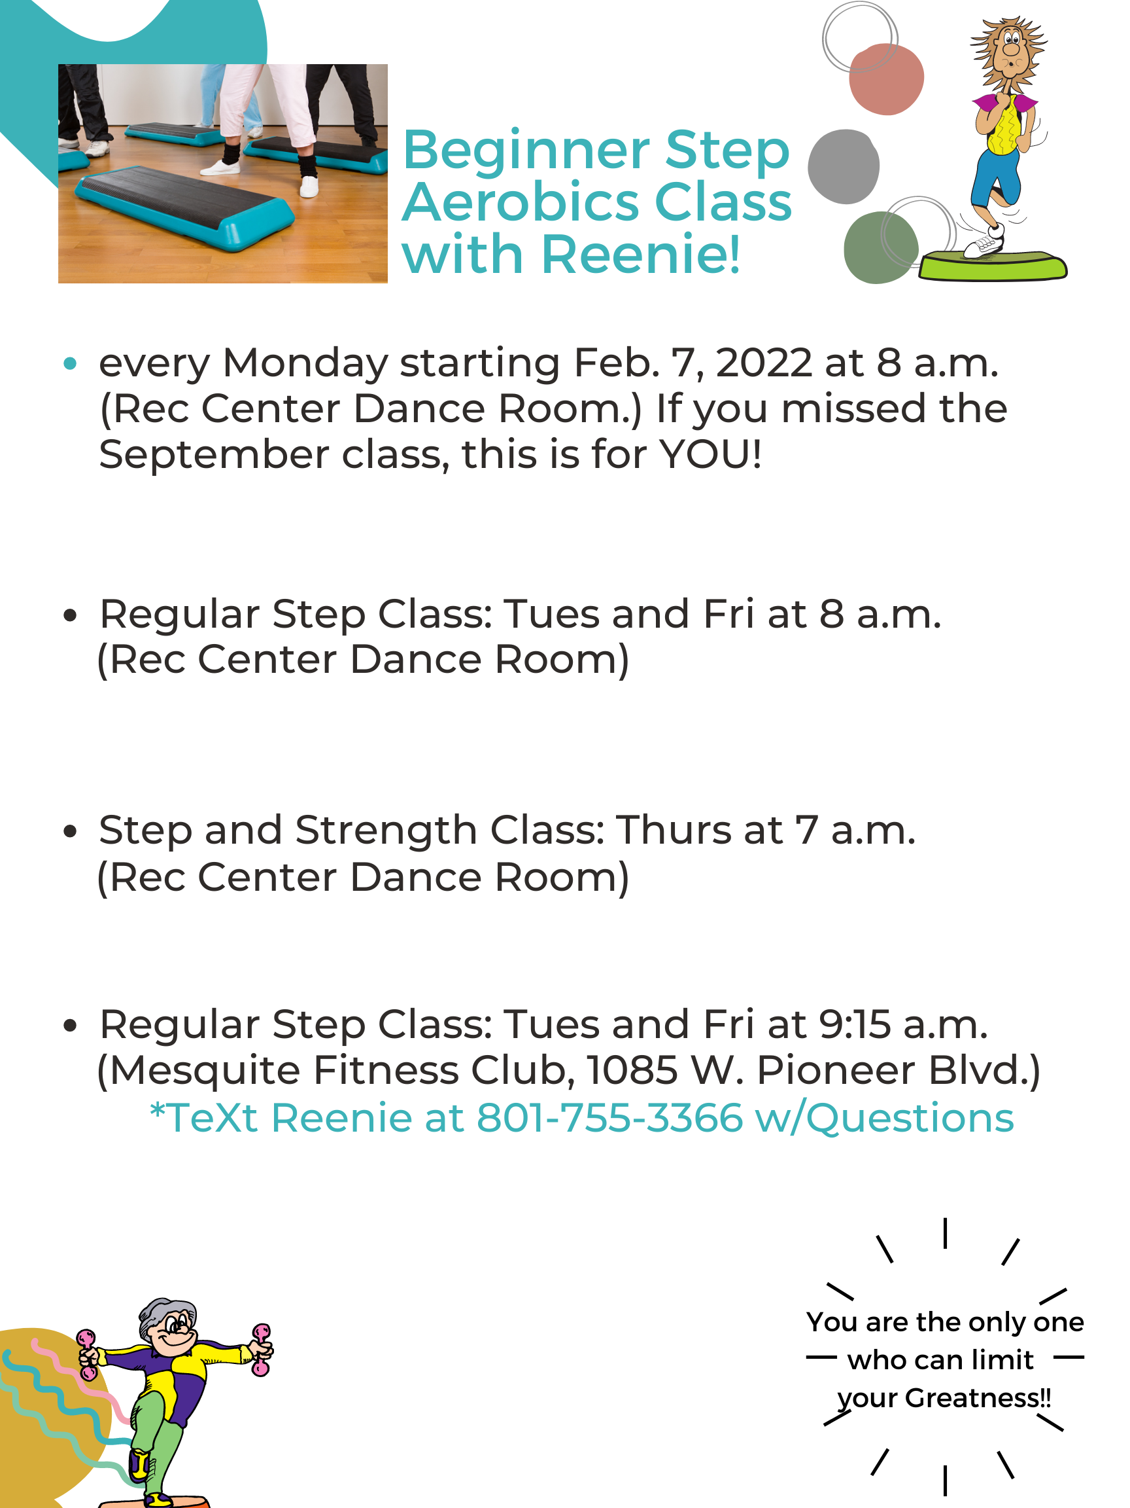

5

6

 |  | 7
  3

8



